EXERCISE NO :10

DATE:23/11/2020

AIM:

To write a python program print the number of upper case letters and lower case letters in a given string.

PROGRAM:

def string_test(s):

d={"UPPER_CASE":0, "LOWER_CASE":0}

for c in s:

if c.isupper():

d["UPPER_CASE"]+=1

elif c.islower():

d["LOWER_CASE"]+=1

else:

pass

print ("Original String : ",s)

print ("No. of Upper case characters : ", d["UPPER_CASE"])

print ("No. of Lower case characters : ", d["LOWER_CASE"])

string_test('Sona College of Technology')

OUTPUT:

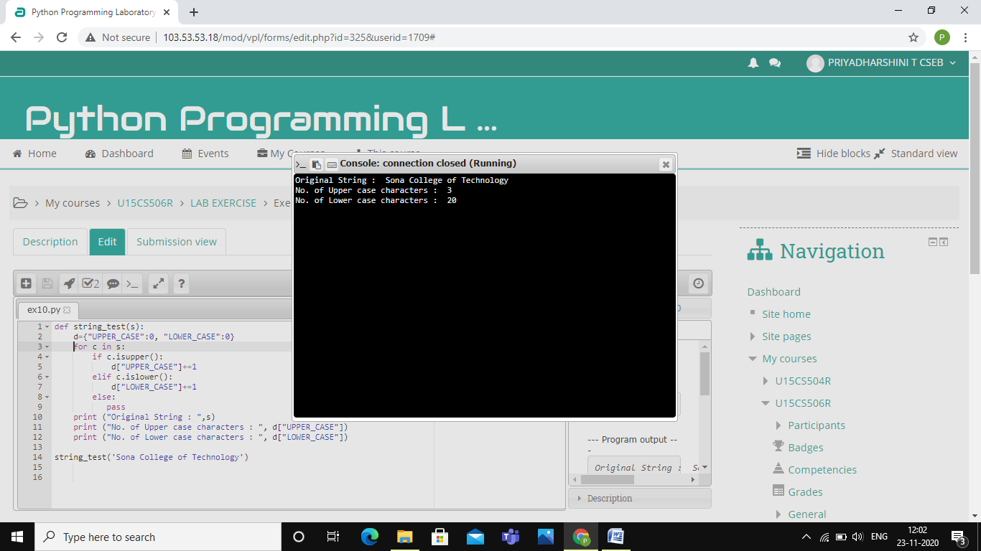

LINK :

<http://103.53.53.18/mod/vpl/forms/edit.php?id=325&userid=1709#>

RESULT :

Thus , the program is successfully executed and output is verified .